MySQL with Node.js

1. MySql Node.js : Connecting to the database
2. Inserting data
3. Update data
4. Delete data
5. Read data
6. Calling Stored Procedures

## Node.js Connection to the MySQL Database:

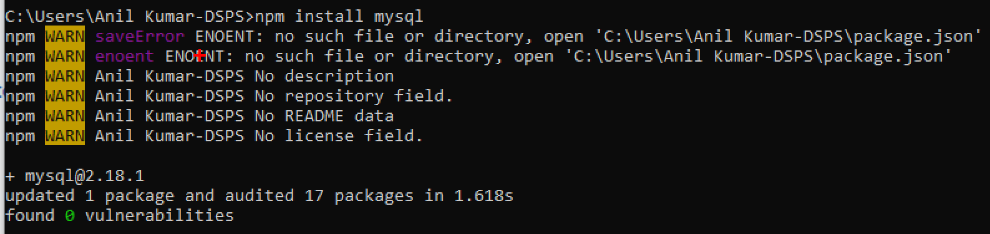

Open the MySQL and execute below commands for changing the privileges

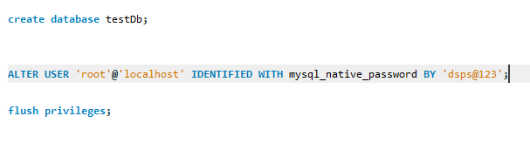

Write the below program and save into same folder

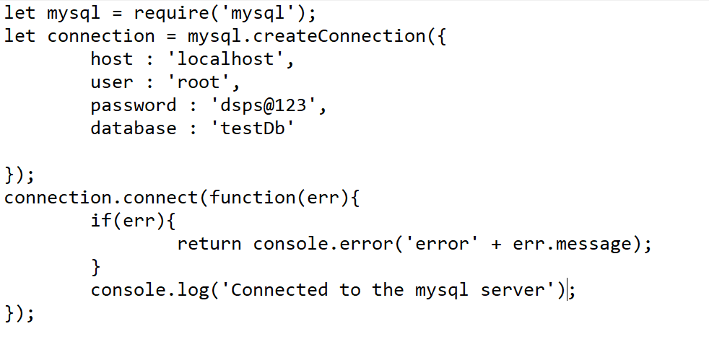

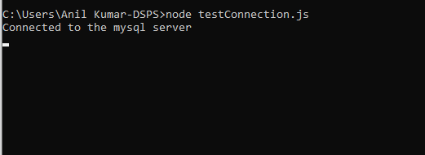

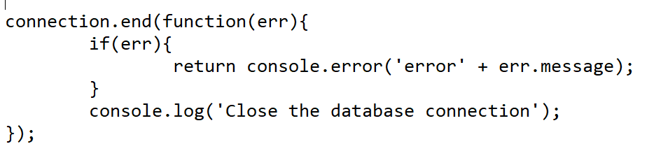

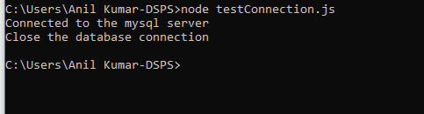

## **Insert Data to the table:**

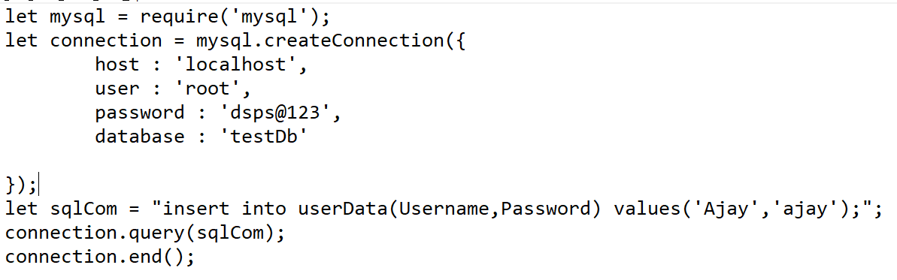

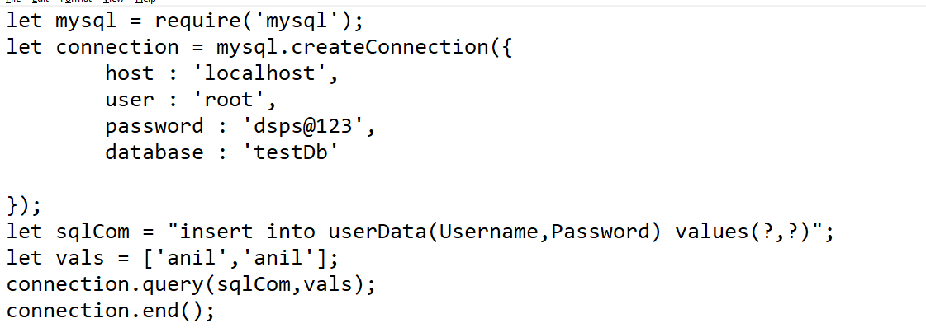



## Let’s make the Connection as Local Module

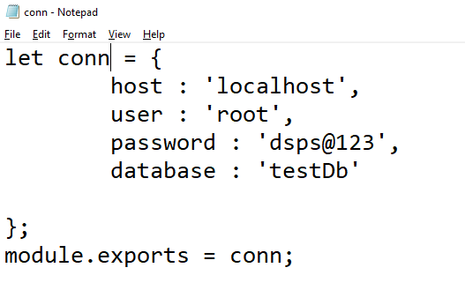

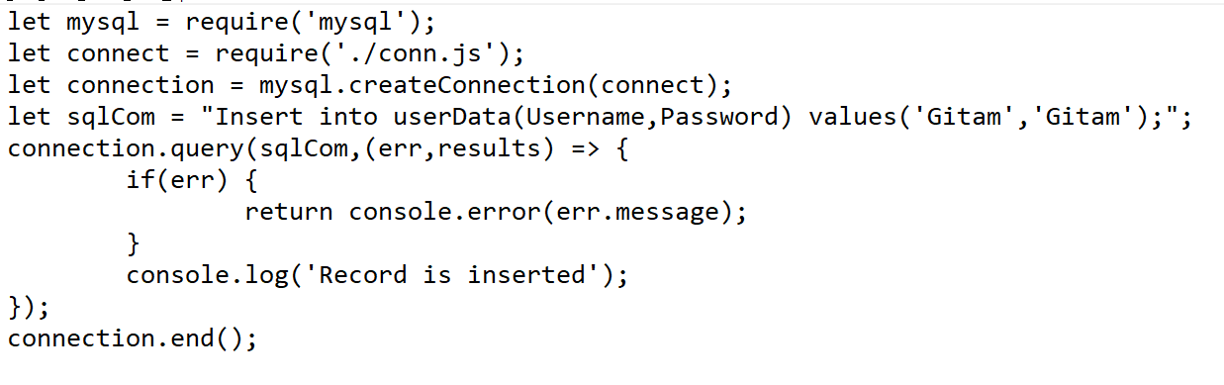

## Insert the Multiple records in a single Insert statement

